**Ex. No.:1C**

**Date: 10/02/2024**

**RAIL FENCE CIPHER**

**Aim:**

To write a Python program to encrypt and decrypt a Plain Text using Rail Fence Cipher algorithm.

**Algorithm:**

1. Get the Plain Text from the user.
2. Set the key as 2 by default.
3. Arrange the Plain Text in two rows in a zig-zag manner.
4. Derive the Cipher Text by adding the first row of arrangement with the second row of arrangement.
5. Get the original text by using the Cipher Text and arranging it in a zigzag manner and repeat the process.

**Program:**

**#Rail Fence Cipher**

def encryptRailFence(text, key):

rail = [['\n' for i in range(len(text))]

for j in range(key)]

#to find the direction

dir_down = False

row, col = 0, 0

for i in range(len(text)):

# to check the direction of flow

# reverse the direction if we have just

# filled the top or bottom rail

if (row == 0) or (row == key - 1):

dir_down = not dir_down

# fill the corresponding alphabet

rail[row][col] = text[i]

col += 1

#find the next row using direction flag

if dir_down:

row += 1

else:

row -= 1

# now we can construct the cipher using rail matrix

result = []

for i in range(key):

for j in range(len(text)):

if rail[i][j] != '\n':

result.append(rail[i][j])

return "".join(result)

def decryptRailFence(cipher, key):

rail = [['\n' for i in range(len(cipher))]

for j in range(key)]

#to find the direction

dir_down = None

row, col = 0, 0

#mark the places with '*'

for i in range(len(cipher)):

if row == 0:

dir_down = True

if row == key - 1:

dir_down = False

#place the marker

rail[row][col] = '*'

col += 1

#find the next row using direction flag

if dir_down:

row += 1

else:

row -= 1

# now we can construct the rail matrix

index = 0

for i in range(key):

for j in range(len(cipher)):

if ((rail[i][j] == '*') and (index < len(cipher))):

rail[i][j] = cipher[index]

index += 1

result = []

row, col = 0, 0

for i in range(len(cipher)):

if row == 0:

dir_down = True

if row == key - 1:

dir_down = False

if (rail[row][col] != '*'):

result.append(rail[row][col])

col += 1

if dir_down:

row += 1

else:

row -= 1

return "".join(result)

if __name__ == "__main__":

pt = input("Enter the PlainText:")

ct = encryptRailFence(pt, 2)

print("Encrypted text:", ct)

print("Decrypted text:", decryptRailFence(ct, 2))

**Output:**

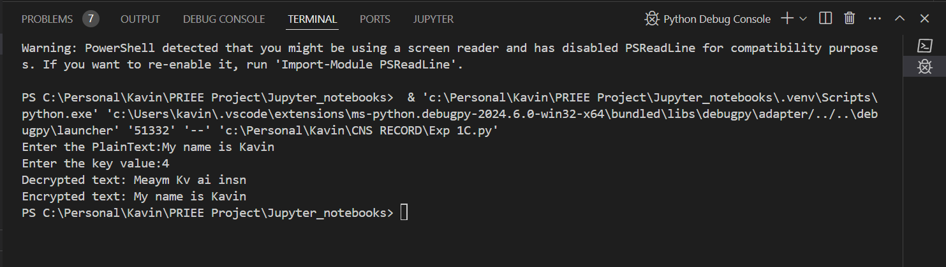

**Result:**

Hence, Rail Fence Cipher program has been implemented successfully.